Installation guide for Database and Server

1. **Database installation - MySQL Server**
   1. Download link : <https://dev.mysql.com/downloads/mysql/>
   2. Go to the bottom of the page, choose the version ---> DMG (find out your laptop’s system information [X64 or X32]. most of laptops are in X64)

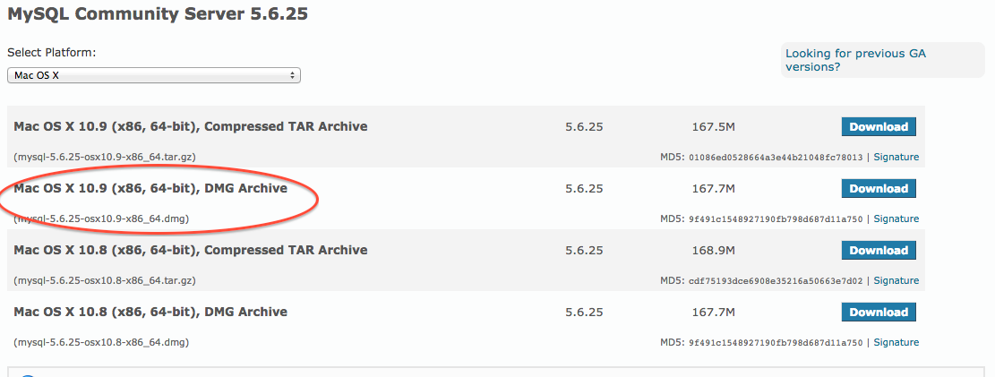

1. **MySQL- Workbench**
   1. Download link : <https://dev.mysql.com/downloads/workbench/>
   2. Go to the bottom of the page, choose the version ---> DMG (find out your laptop’s system information [X64 or X32]. most of laptops are in X64)

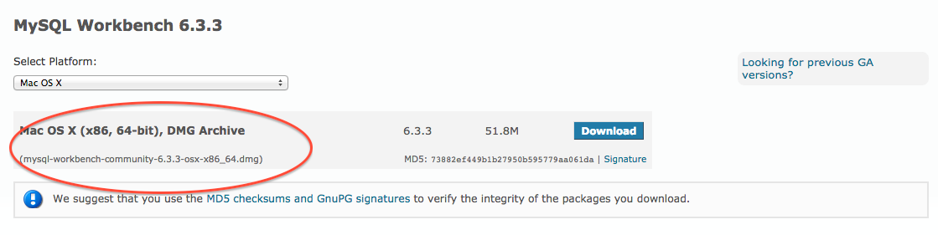

* 1. After the installation is done, open your System Preference. You will see this screen.

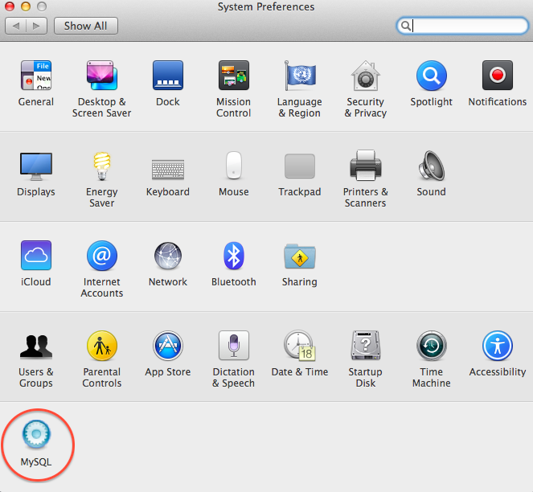

In the corner, we will see MySQL (server) open and run it.

Then open your MySQL workbench and set up a new user

**Name: root**

**Password: null**

Click test connection button to test if we could connect to MySQL Server.

If successfully, then it’s done.

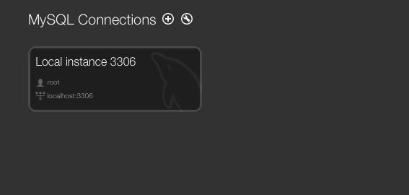

1. **Server installation – Eclipse**
   1. Download link : <https://www.eclipse.org/downloads/>
   2. Download Mac OS X64 Bit Version.

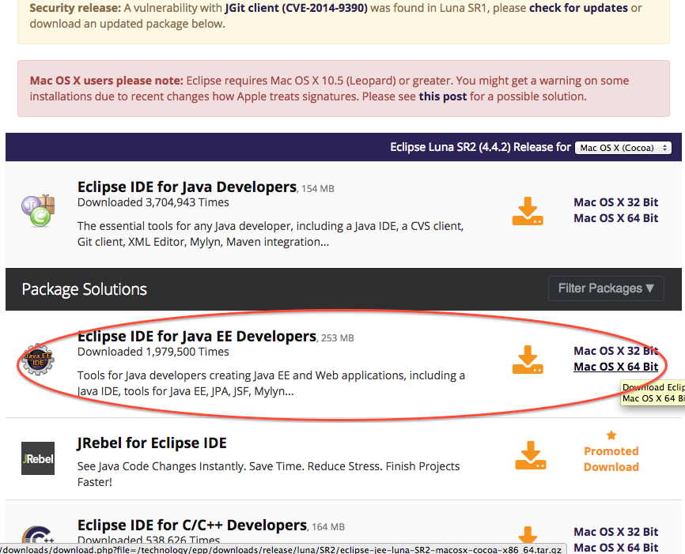

* 1. Extract the .zip file and run Eclipse .exe
  2. Download server project and extract it. Then Import the project.

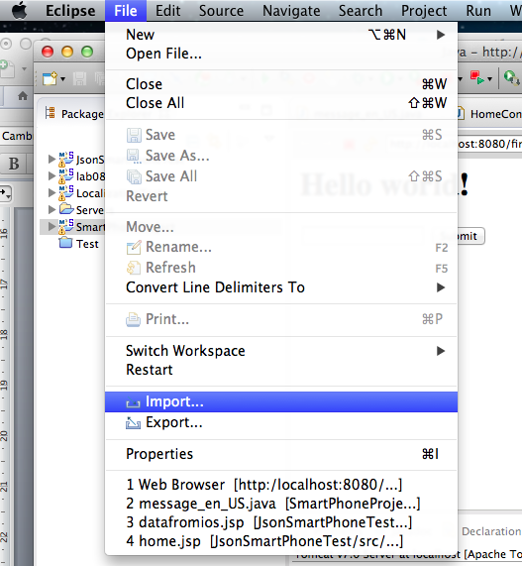

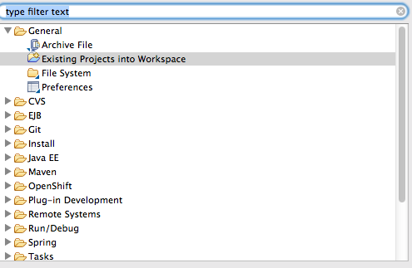

1. **Install Tomcat Apache**
   1. Download link : <http://tomcat.apache.org/download-80.cgi>
   2. Download zip file and extract it.

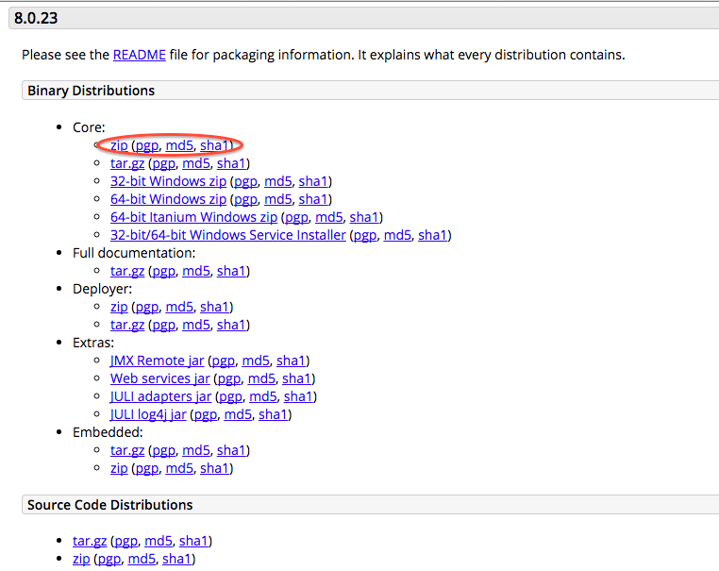

* 1. Go back to your Eclipse
  2. In the bottom of the interface, choose Servers and click add new Server

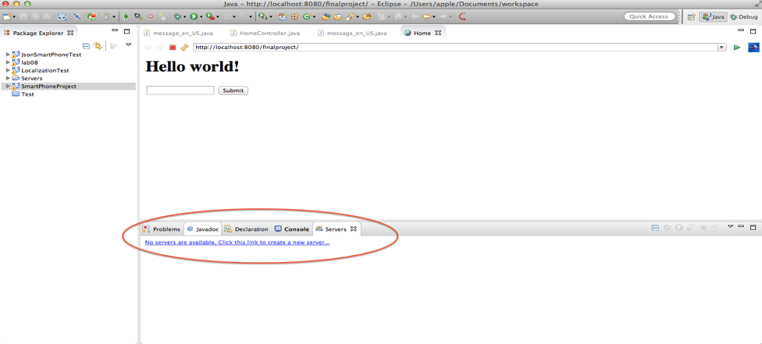

* 1. Choose the version you have downloaded. It should be Tomcat 8.0

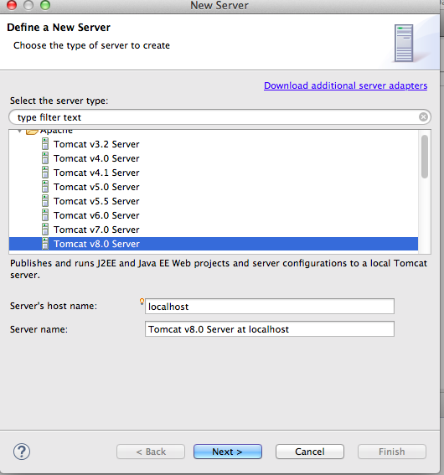

* 1. Browse the laptop, find the Tomcat folder. The URL should be like this.
  2. After all of these have been done, run the project on server.

